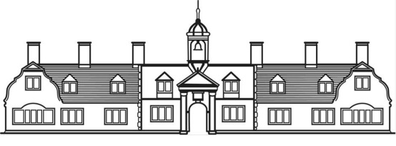
Lifelink Disclaimer
The Ann Edwards Charity
Church House
5 Denmark Road
Gloucester GL1 3HW
01452 410022

The Ann Edwards Charity provides a free Lifelink personal alarm to all residents who require one, for your personal safety. Residents who decide not to have a Lifelink alarm are required to sign this disclaimer, confirming your decision.

Full name……………………………………………………………………………………………………………………...............................

Address……......................................................................................................................................................

........................................................................................................................................................................

Date of Birth………………………….………………................................................

I declare that I have chosen not to use a Lifelink personal alarm. I understand that I can request an alarm at any time, and that the Charity may contact me from time to time, to see if my circumstances have changed.

Signature........................................................................................................................................................

Date …………………………………………

