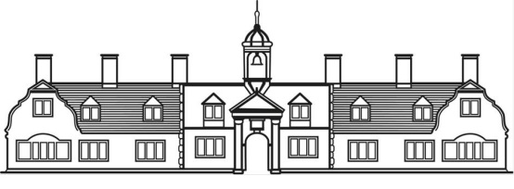
GP Authorisation form

Charity of Ann Edwards

I [full name in capitals] ……………………………………………………………………..……………………………………

whose date of birth is …………………………………………………………………………………………………………..

of address: …………………………………………………………………………………….………………………………………

………………………………………………………………………………………..……………………………………………………..

Authorise my GP for the time being and all my other medical advisors for the time being to provide information about my health and any aspect of my medical condition upon request
to the Charity of Ann Edwards Registered Charity No 263956) (“the Charity”), both in connection with any application I make to become a resident of almshouses provided by the charity and at any time thereafter until I have ceased to live in the property provided by the Charity.

GP’s name: …………………………………………………………………………………………………………………………….

GP’s address: …………………………………………………………………………………………………………………………

……………………………………………………………………………………………………………………………………………….

……………………………………………………………………………………………………………………………………………….

Signed by applicant: ………………………………………………………….…………………………………………………..

Date of signature: ………………………………………………………………………………………………………………….

Reviewed June 2026

