

Responding Safely to Safeguarding
Concerns and Allegations

The Rector and the PCC are required to have a procedure in place to deal promptly with safeguarding allegations or suspicions of abuse.
All safeguarding concerns or allegations (including against church officers) must be reported to the Parish Safeguarding Officer, the Rector and then to the Diocesan Safeguarding Team.
The flow chart below gives a step-by-step guide to the correct reporting procedure.
The Parochial Church Council adopted this procedure on: DATE
Rector: PCC Secretary:

Contact Information:

Incumbent (Rector): NAME
Contact:
Parish Safeguarding Officer (PSO): NAME
Contact:
Diocesan Safeguarding Adviser (DSA): NAME
Contact: PHONE NUMBER AND EMAIL
Local Authority Children Social Care:
Contact: Include out of hours number
Local Authority Adult Social Care:
Contact: Include out of hours number

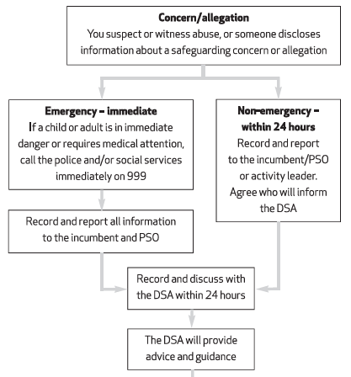

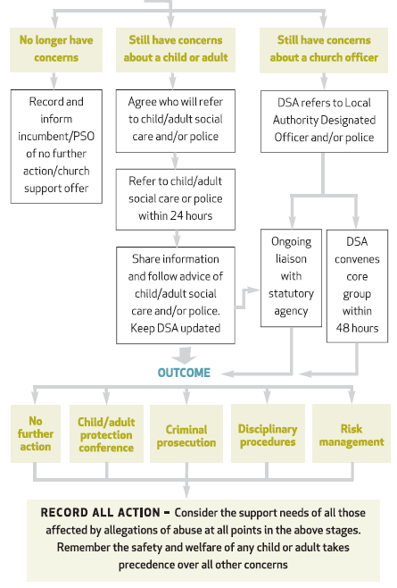

What to do if you are concerned about a child or adult and/or you are concerned that a church officer may be abusing a child or adult

1. Respond well to the victim/survivor, if it is a direct disclosure, ensure they feel listened to and taken seriously. Explain what will happen next and check out support requirements. They should be informed that their identity and the identity of the respondent will be shared with key church officers, and may be shared with the statutory agencies, if there is any current risk to children or adults. The concern or allegation should not be shared with anyone other than those who need to know (e.g. the statutory agencies and appropriate church officers.

2. Emergency: If you believe a child or adult is in immediate danger of significant or serious harm, contact the emergency services on 999.

3. Non-emergency: Contact the Parish Safeguarding Officer or incumbent, in the first instance. They must then contact the DSA. If neither are available, contact the DSA directly. If the concern arises in an activity, discuss with the group/activity leader, who will contact the Parish Safeguarding Officer or incumbent.

4. Any safeguarding concerns must be reported to the DSA within 24 hours.

5. If the PSO/incumbent or the DSA are not available within 24 hours, contact Children’s Social Care or Adult Social Care and/or the police directly, if the concern is that a child or adult is being abused. Contact the Local Authority Designated Officer (LADO) and/or police if the concern is that a church officer may be abusing a child or adult. Advise the Parish Safeguarding Officer or incumbent as soon as possible that you have made a referral; they will advise the DSA.
If in doubt don’t delay – seek advice from statutory agencies.

6. Do not contact the respondent or anyone who may be implicated in the allegation or disclosure, even if they would normally be contacted as part of the procedure, until advice has been sought from the DSA or statutory agencies.

7. Record the details of the concern or allegation. Where it is not appropriate to take notes at the time (usually it will not be), make a written record as soon as possible afterwards or before the end of the day. Record the time, date, location, persons present and how the concern or allegation was received, e.g. by telephone, face-to-face conversation, letter, etc. The record should include details of information provided to that person as well as the information received. Always sign and date the record. Keep it factual. Pass on a copy to the DSA (and/or the PSO/incumbent). The records should be kept secure and confidential.

