
Events and training
More details for all these events at gloucester.anglican.org/events
NeoAncients, St Laurence Church, The Shambles, Stroud, GL5 1JL, 1 to 3 May A three-day folklore festival with music, art, film, talks, books, dance ritual and lore. https://stlaurencestroud.uk/event_custom/neoancients/

Wild Worship at Tewkesbury
Abbey, Church Street,
Tewkesbury GL20 5RZ, 3 May, 3pm to 4pm
An informal, family-friendly
outdoor service giving thanks for the beauty of creation. All ages are welcome.
https://www.tewkesburyabbey.org.uk/eco-church/



The music of Coldplay by candlelight, Tewkesbury Abbey, GL20 5RZ, 9 May, 6.15pm and 8.30pm A concert of Coldplay songs featuring a live band and vocalists, coming from the West End. https://boxoffice.concertsbycandlelight.com/events/kindadustyltd/2040110

Music festival at Chipping Campden, St James Church, Church Street, Chipping Campden, GL55 6JG, 11 to 23 May A classical music festival featuring 17 concerts over two weeks, with performances from world-class artists. https://www.campdenmayfestivals.co.uk/music/events

From 14 to 24 May 2026, Christians around the world will once again unite in prayer as part of Thy Kingdom Come.
This year’s theme, ‘God with us’, focuses on the presence of God through His spirit. It reminds us that God is not distant but involved in the everyday moments of our lives – in both joy and sorrow and everything in between.
Taking place during the eleven days between Ascension Day and Pentecost, this global movement invites us to pray for more people to come to know Jesus, while also renewing our own faith in the power of prayer.

Throughout these eleven days, Christians are invited to take part in daily reflections, drawing on stories from scripture such as the story of Ruth and the story of Gideon. Each is intended to reveal something of God’s transformative presence, faithfulness and power that’s at work in ordinary people and situations.

As we reflect and pray, we are invited to recognise that same

Thy Kingdom Come 2026: ‘God with us’
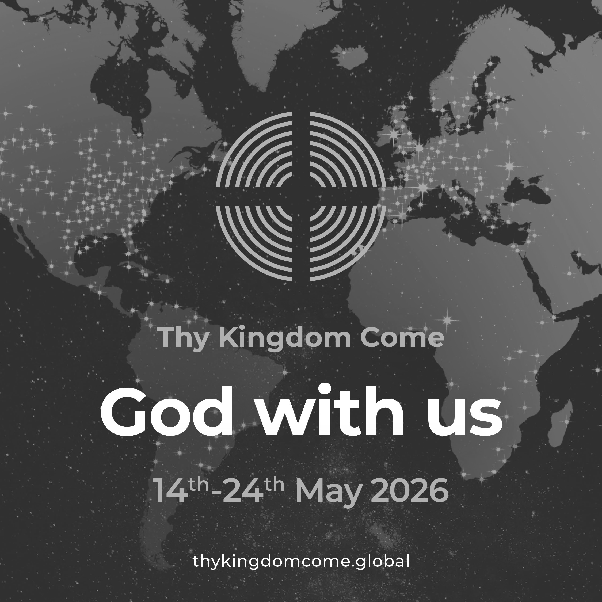
The Messenger May 2026
Faith stories: Barnaby’s transformation
24-year-old Barnaby worships at Trinity Cheltenham, where becoming part of the community has profoundly shaped his life. Through Trinity’s SPEAR programme he has gained confidence, employability skills, and a renewed purpose, while also exploring the Christian faith through Alpha – a journey that led to his baptism.
“In March 2023, I met two SPEAR representatives at the job centre. This was when my trajectory changed,” Barnaby said. “They were so kind and encouraging, and they suggested I take part in the SPEAR programme.”
Through SPEAR, he completed employability training and learnt the importance of confidence and communication, while being surrounded by people who believed in his potential.
“It introduced me to a supportive community. They encouraged me to try the Alpha course, and this was the big turning point for me spiritually. Alpha really ignited my faith, and it was the moment when I decided I wanted to follow this.”
Barnaby has been attending Trinity for around two years and was baptised in March.
“The first time I went to church, I had a really strong experience… it’s been transformative. It’s been so good for my mental health.”
He now works at The Armoury gym and continues to stay involved with SPEAR, returning to SPEAR celebrations to share his story.
Read Barnaby’s full faith story at https://gloucester.anglican.org/2026/faith-stories-barnabys-transformation/

presence at work in our own lives and communities. At its heart is an invitation to pray each day for five people we know - whether it be friends, family, neighbours or colleagues – that they might encounter the love of Christ.
As churches and individuals across our diocese and beyond join in, this is an opportunity to come together with a shared purpose, trusting that God is at work in the lives of those we hold before Him.
Whether you are new to prayer or have taken part in previous years, Thy Kingdom Come offers a fresh opportunity to join this global wave of prayer. Individuals, households and churches are all encourage to take part in ways that feel natural and meaningful to them – through personal devotion, small groups, or gathered worship.

To help individuals and churches get involved this year, there are a range of free resources on the Thy Kingdom Come website to help guide you through; this includes daily prayer resources (Novena) written by Archbishop Sarah Mullally, a 2026 prayer journal, and practical ideas for ways your church can take part → visit https://www.thykingdomcome.global/resources-0

Christian Aid Week 2026

Christian Aid Week takes place from 10 to 16 May. This year, Christian Aid is focusing on supporting mothers in Nairobi, Kenya, as they face urban poverty and the daily challenge of providing food for their children. Churches can take part in Christian Aid Week in a variety of ways, including collections, fundraising events, prayer, and raising awareness. Further information is available at https://caw.christianaid.org.uk

