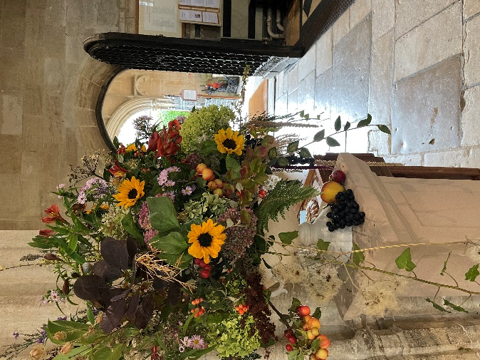

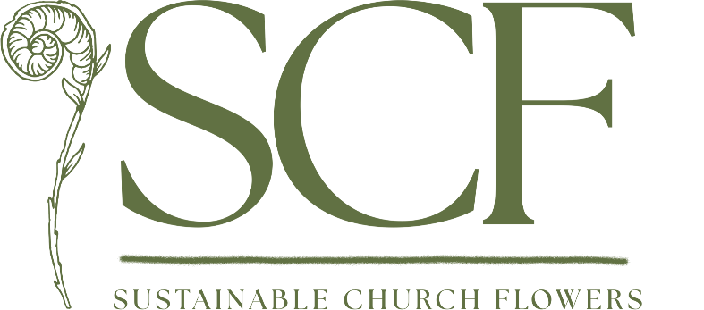

“The vision of Sustainable Church Flowers is to reduce pollution in our floral decorations by using carbon neutral flowers and less plastic.

Glorifying God Sustainably”

Sustainable Church Flowers are
Biodegradable, Local, Seasonal and Foam-Free

Sustainable Church Flowers (SCF) was launched in 2019 in the Diocese of Worcester. It promotes action for change in church flower arranging using floral ambassadors, workshops, demonstrations, leaflets and social media. Royal florist Shane Connolly is a founder member.

The environmental impact of imported and hot-house flowers
- High water usage in areas where water is scarce
- Heavy use of pesticides causing water pollution for local people
- Often poor and hazardous working conditions for vulnerable workers
- Single use plastic wrapping
- Fossil fuels to heat greenhouses and for refrigeration in transit
- Fossil fuels for transportation by air, road and sea
- Up to 10 times carbon footprint of British-grown flowers (RHS research)

Choosing sustainable flowers
- British-grown seasonal flowers are ideal
- Pick from gardens, churchyard or hedgerows
- In winter, supplement arrangements with dried flowers, seed heads and grasses
- In winter, flowers can be ordered from Cornwall and the Scilly Isles
- In winter, bowls of flowering bulbs or plants can be used instead of cut flowers
- Supermarket flowers showing the Union Jack symbol to show that they are British-grown
- Fairtrade flowers guarantee improved worker conditions and fewer chemicals, although they still have a heavy carbon footprint
- Flowers from the Farm www.flowersfromthefarm.co.uk website lists British growers
- Farewell Flowers is an online directory of sustainable funeral flowers www.farewellflowers.co.uk
- Avoid plastic wrapped flowers where possible
- Avoid flowers that are dyed, or with added glitter

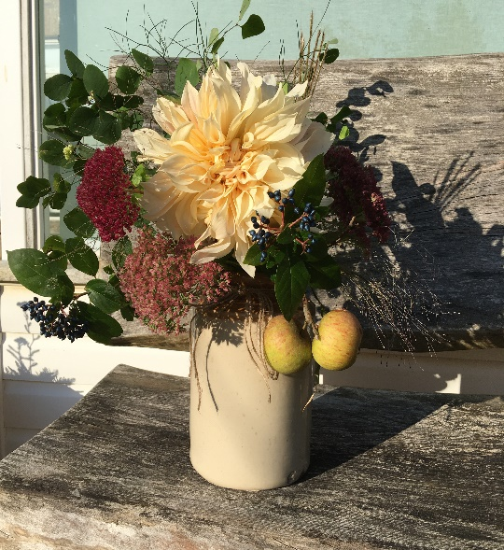
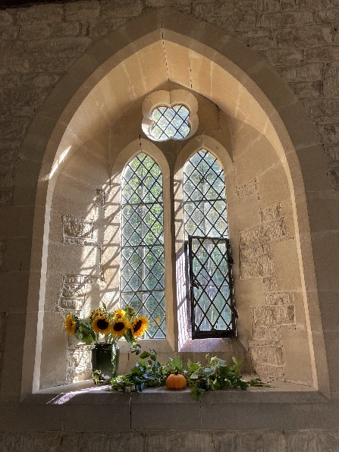

The Environmental Impact of Floral Foam
- Floral foam, under the tradename ‘Oasis’, was introduced in 1954
- Single use, non-recyclable product that must be disposed of in landfill
- Not compostable (although is often mistakenly added to compost heaps)
- Not suitable for disposal in garden waste bins
- Does not burn
- Contains known carcinogens
- Breaks down into micro-plastics, contaminating rivers, lakes and seas
- Micro-plastics harm aquatic life at the bottom of the food chain
- ‘Bio Foam Oasis’ is still around 51% biodegradable (under ideal landfill conditions). The remaining 49% therefore, can contaminate soil and waterways in the form of microplastics for hundreds of years
- Oasis banned by The Royal Horticultural Society at all its shows since 2020
- There are new foam products coming to the market. None have yet been approved as having fully sustainable credentials.

Some sustainable methods for arranging flowers
- chicken wire
- floral frogs/Kenzan/pinholders
- twisted or criss-crossed twigs
- marbles, pea shingle, sand
- wooden, metal or bamboo grids
- taped vases
- jam jars of water inside a container (e.g., trough or basket)
- mossages (moss wrapped in chicken wire), garlands and wreaths
- stems directly in water in a vase
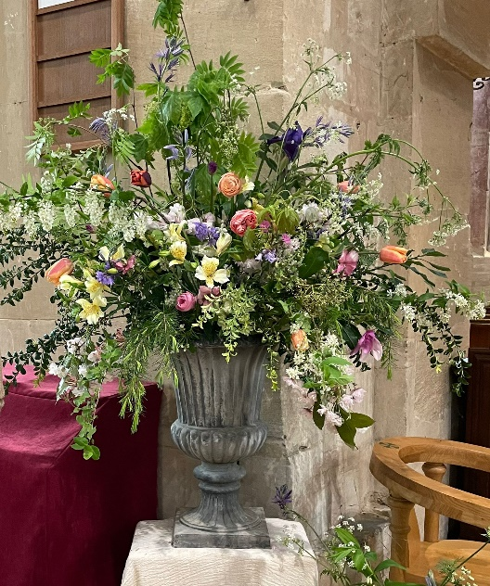
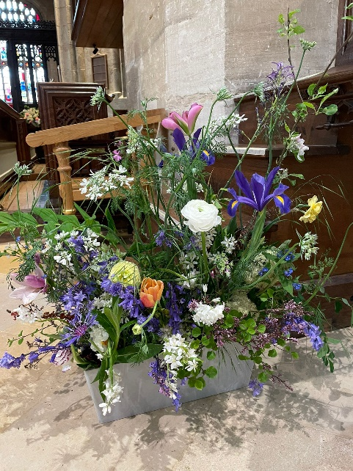

Positive Choices
Positive change is easier if we work together to foster a supportive network in our churches and flower teams, allowing us to make informed choices towards more ethical, nature-friendly and sustainable church flowers. In doing this we help to fulfil the fifth mark of mission of The Church of England:
“To strive to safeguard the integrity of creation and sustain and renew the life of the earth.”
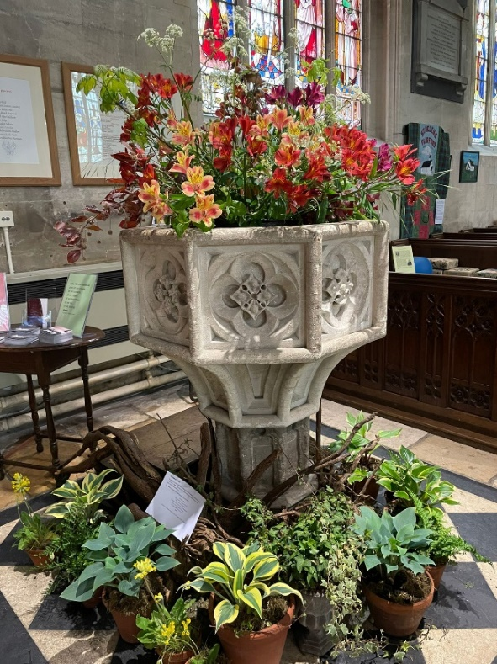
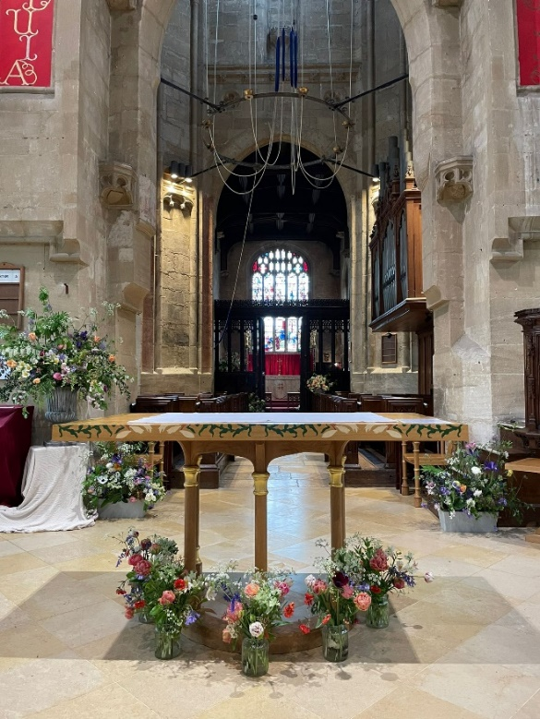

A plastic bucket with chicken wire supports flowers in this font arrangement and glass vases are grouped together around the altar.
https://suschurchflowers.com
Church-flowers-and-sustainability.pdf (arocha.org.uk)
Beth Bruce-Gardner

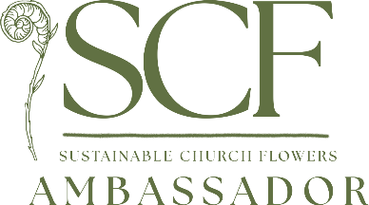
07791 841202 beth@honeymoonfern.com

