# Building a robust support for ministry in Gloucester Diocese

# Overview

In order to support all ministry across our Diocese, we are building a framework, offering different levels of support for different seasons and situations. These will include;

1. One-to-one facilitation
2. Spiritual Direction
3. Diocesan Counselling service and Occupational Health
4. Reflective Ministry Groups
5. Professional Coaching
6. Coaching for Teams
7. Mentoring
8. 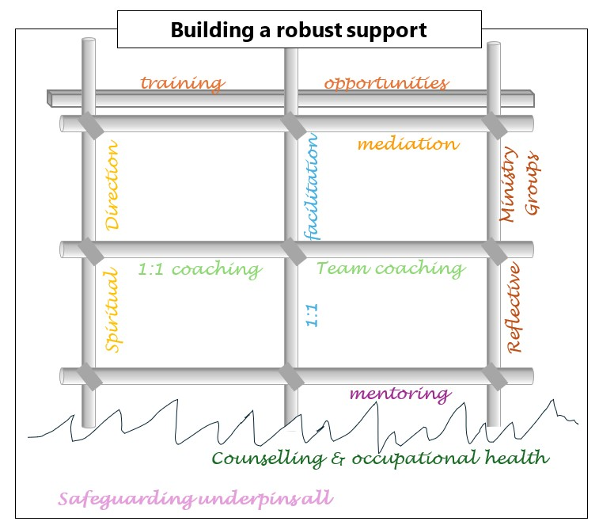Mediation

Some of these are well established, some are just beginning to develop, but together we hope that they will ensure that everyone has access to input that is appropriate for them.

Within each of these offerings, unless something is disclosed that is indicates that there are concerns about the person's safety or that of others everything will be in strict confidence, and no reporting back will be done. If something does need to be shared outside the session this will be made clear to the individual unless to do so would put them or others at further risk of harm.

All enquiries can be made via Kate Stacey: [kstacey@glosdioc.org.uk](mailto:kstacey@glosdioc.org.uk) using this form and will be triaged to ensure the most appropriate support is provided.

# One-to-one facilitation: providing space and support to think through a specific situation or challenge

## What 1:1 facilitation is, and what it is not

This is a facilitated conversation whereby the person knows something at the end of the conversation that they didn’t know at the beginning. So this process can help you explore issues, make a decision about a next step in a process, help you scope out a complex web of relationships, start a project and so on. It is most effective when you are in a good place with the time and energy to give to your personal development. A facilitator can help in a crisis but the focus then is more on survival than personal development – prevention is always better than first aid.

This process does not depend on the facilitator being more experienced than you; it is not about someone giving you advice. It is based on a deep understanding that you have all the resources you need within you – all you need is someone to help you uncover them.

These facilitated conversations are not Spiritual Direction, where the focus is on your relationship with God, though it goes without saying, your walk with God will be part of the conversation and thinking and may well allow you to find ways of developing your relationship with God.

Neither are they Counselling. This is not the right space to process complex emotions, though it will be understood that these may well be part of the deep thinking and talking that will be the work of these sessions.

We are developing a team of trained people to offer this one-to-one work, who themselves will be engaging in their own work and ongoing development, as you are.

## Meetings

* The first meeting is a maximum of 1.5 hours allowing half an hour to discuss the process, the way you want to work, and looking through the agreement, and the intervals between sessions and 1 hour for 1:1 support
* A further two sessions of 1 hour maximum followed by a review
* The 1:1 support may continue for a further three sessions followed by a review
* It would not be expected for the 1:1 support to continue beyond six sessions
* Following 1:1 support, people will be expected to join a supervision group if they do not already belong to one

## Practicalities

* Those receiving support would ordinarily travel to the facilitator. However, if that is not possible, travel expenses are available for facilitators
* Alternatively, it may be agreed that sessions happen online
* If the 1:1 support is felt to remain useful after six sessions, there would be a conversation between Kate, the facilitator and the person receiving 1:1 support to discuss next steps
* If it is felt the situation is too complex, a referral for professional coaching may be made [see 5]
* The Diocese will commit to the safer recruitment, support, training and group supervision to all people engaged in delivering 1:1 support

# Spiritual Direction: space to attend to your relationship with God

## What Spiritual Direction is, and what it is not

Spiritual Direction, sometimes referred to as Spiritual Accompaniment, is someone to travel with you, often over a longer time, as you grow in your relationship with God. Spiritual Direction is not about being directive, but a work of great humility in the services of transparency to the Holy Spirit.

Spiritual Direction looks to deepen your prayer life, offer a safe space of profound listening that enables you to articulate your thoughts and feelings around your life of faith. The Spiritual Director will first and foremost seek to listen to the Holy Spirit, and encourage the directee to do so as well, honing their practice of discernment. It will be based on a clear agreement, without judgement, and the Spiritual Director will be clear when the issues raised require a different kind of support [e.g. coaching or counselling].

Spiritual Direction is not having someone who will fix things or offer advice. It is not unboundaried access to the person, and the relationship should never become mutually dependent.

## Meetings

* The first meeting is a maximum of 1.5 hours allowing half an hour to discuss the process, the way you want to work, and looking through the agreement, and the intervals between sessions
* Further sessions of 1 hour maximum with an annual review

## Practicalities

* To request a Spiritual Director, make direct contact with the [Gloucestershire Spiritual Direction Trust](mailto:•%09spiritualdirectionglosenquiries@proton.me)
* Those receiving Direction would ordinarily travel to the Spiritual Director. However, if that is not possible, travel expenses are available for Spiritual Directors
* It may be agreed between the parties that online meetings are more appropriate
* The Spiritual Directors will commit to seeing their own Spiritual Directors, having regular supervision and appropriate training and insurance

# Diocesan Counselling Service and Occupational Health: when thing threaten to overwhelm

## What Counselling and Occupational Health are, and what they are not

A limited range of people are able to refer themselves independently to the Diocesan Professional Counselling Service. Information can be obtained from the [Director of People and Pastoral](mailto:aclarke@glosdioc.org.uk) in the strictest confidence. This service offers psychological support for a limited time and is not long-term psychotherapy.

In addition, the Diocese offers further advice and support around occupational health for clergy and Diocesan Staff through Health Assured; again, details are available from the [Director of People and Pastoral.](mailto:aclarke@glosdioc.org.uk) Unfortunately, there is not capacity to offer these services more widely to other ministers.

## Meetings

* The first meeting is a maximum of 1.5 hours allowing half an hour to discuss the process, the way you want to work, and looking through the agreement, and the intervals between sessions
* 5 further sessions of 1 hour maximum
* If it is felt that further sessions are required, that is by arrangement between the parties

## Practicalities

* Those receiving Counselling would ordinarily travel to the Counsellor
* It may be agreed between the parties that online meetings are more appropriate

# Reflective Ministry Groups: meeting with others to reflect, support and learn

## What Reflective Ministry Groups are, and what they are not

Reflective Ministry Groups are up to 6 people, with a trained facilitator, meeting bimonthly to help one another reflect on aspects of ministry, support one another, and learn together. We are investing in building capacity so that each person ministering, in whatever capacity, will have access to this vital aspect of support, accountability and resilience in ministry.

Initially, those starting out in ministry, and those moving from one ministry to another, will be strongly encouraged to be part of a Reflective Ministry Group. Once more capacity has been built, this will be opened up more widely.

These are neither therapy groups nor social groups.

## Meetings

* The first meeting is a maximum of 2 hours allowing half an hour to discuss the process, agree protocol, and set dates for the sessions
* The groups will meet bimonthly with the duration being agreed by the group

## Practicalities

* The first meeting will be in person, where the group will decide if they would prefer to continue to meet in person or be an online group [which may be dictated by geography]
* Experience from those who have been in these groups suggests that bimonthly is a good pattern – less reduces their efficacy significantly
* Members of the group need to commit to making this a priority [e.g. say no to a funeral that is requested that clashes with an agreed meeting]
* The Diocese will commit to offering support, training and group supervision to all people engaged in facilitating RMGs

# Professional Coaching: for more complex circumstances or situations

## What Professional coaching is, and what it is not

Professional coaching will be delivered by a qualified [or someone in the latter stages of becoming qualified] coach. They will create space for deep thinking through asking excellent questions. To be effective, trust and confidence needs to be established. This process allows the person being coached to find the answers within themselves. If it is felt that a situation is too complex after 1:1 facilitation, this may be the next step.

It is not directive or long term. The coach will not be an expert in your situation.

## Meetings

* The first meeting is a maximum of 1.5 hours allowing half an hour to discuss the process, the way you want to work, and looking through the agreement, and the intervals between sessions and 1 hour for coaching
* A further two sessions of 1 hour maximum followed by a review
* The coaching may continue for a further three sessions ending with a review

## Practicalities

* Those receiving coaching would ordinarily travel to the coach, unless they specify another location
* Alternatively, it may be agreed that sessions happen online
* The Diocese will ensure that coaches are appropriately trained, insured and in supervision themselves
* The cost of this will be split three ways between the Mission and Ministry department, the PCC of, and the person receiving the coaching

# Coaching for Teams: to enable great working relationships and shared vision holding

## What Team coaching is, and what it is not

This coaching would be more specifically aimed at whole teams, helping leaders and teams wrestle with their key challenges and opportunities and to recognise what is helping and hindering their progress and likely success. Each of our ministry teams engaging with a coach is a key hope of our Senior Leadership Team in the Diocese. This type of coaching enables the team to appreciate their ability to make the changes, to work more cohesively and openly, respecting and valuing each other’s strengths and weaknesses and finding better ways forward where they, and those they serve, can flourish.

Team coaching will be delivered by a coach who is qualified and has experience in this specific role. To be effective, trust and confidence needs to be established between the team and the coach, and each member of the team. The team need to be prepared to work hard and collaboratively. This will be by invitation.

It is not directive or long term. The coach will not be an expert in your situation. We do not currently have capacity to offer this beyond the formally constituted Team Ministries but do want to find ways of offering this to a more diverse range of ministry teams.

## Meetings

* This will be a far more bespoke offering, negotiated between the coach and the team in conversation with the Collaborative Ministry Lead: Life-long Learning

## Practicalities

* Likewise, these will be worked out in a three-way conversation to suit the specific needs
* The Diocese will ensure that coaches are appropriately trained, insured and in supervision themselves

# Mentoring: a light touch, friendly voice of experience

## What mentoring is, and what it is not

Mentoring is a longer-term relationship between someone in earlier stages of their journey and someone who brings more experience. Unlike facilitation or coaching, mentoring can be much more directive – the mentored needs advice or information, and the mentor can offer it. Where you have a question but are not sure that it is something you should be in touch with the Archdeacon about [for instance], in the confidence that the Mentor will be able to signpost you where necessary. This relationship helps the mentored to develop and discern goals.

Mentors do not have a professional qualification and is far less structured and unlikely to involve regular meetings.

## Meetings

* May be someone on the end of the phone, or occasional meet for coffee – very flexible

## Practicalities

* If meeting face to face, the mentored would usually travel to the mentor
* The Diocese will ensure that mentors are appropriately supported

# Mediation: helping navigate difficult conversations

## What mediation is, and what it is not

Mediation is a structured approach of face-to-face dialogue to enable people to address their conflicts with each other in a safe environment with an experienced mediator present. The mediator will lead a process that encourages open and honest communication between those involved so that each can hear the other and find creative ways through.

Mediation cannot be obligatory. The mediator is not there to take sides, judge or offer solutions.

## Meetings

* Will be structured and conducted in a private, mutual space
* It may be agreed by all parties that a second session is necessary

## Practicalities

* Travel expenses, and room hire costs will be available to the mediator
* The Diocese will ensure that mediators are trained

Underpinning all of this are a host of Training opportunities to build you in your ministry, and an openness to any suggestions you have for training that would support you – if you are thinking it, there is a high chance that others will be too! Contact Kate Stacey: [kstacey@glosdioc.org.uk](mailto:kstacey@glosdioc.org.uk)

If you are concerned about a person, or a situation, our Safeguarding team can be contacted at any time, and are very responsive. If it doesn’t feel right, it’s better to check and it all be fine. Contact Brett, Becca or Mel: [safeguarding@glosdioc.org.uk](https://diog.sharepoint.com/sites/MissionandMinistry/Shared%20Documents/Collaborative%20Ministry%20LLL/Supervision/safeguarding@glosdioc.org.uk)